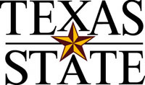
Department of
Family & Consumer Sciences

601 University Drive
San Marcos, Texas 78666-4616
Office: 512.245.2155
Fax: 512.245.3829
www.fcs.txstate.edu

Dear Participant,

Thank you for participating in this research study. Enclosed is a $10 gift certificate to the HEB grocery store that can be used at a location of your choice. We appreciate your contribution to this study!

Cordially,

Dr. Sylvia Crixell
Texas State University
San Marcos, Texas

